Sample Confidentiality Statement and Customizable Confidentiality Letters

Sample Confidentiality Statement
The Bright Futures Guidelines, 4th Edition, includes a sample confidentiality statement: “Our discussions with you are private. We hope you will feel free to talk openly with us about yourself and your health. Information is not shared with other people without your permission unless we are concerned that someone is in danger.” Author: Jack Mayer, MD, MPH, Rainbow Pediatrics, Middlebury, VT.

Customizable Confidentiality Letters
Below are example confidentiality letters for adolescents and parents from the AAP Mental Health Toolkit that can be customized for your practice.
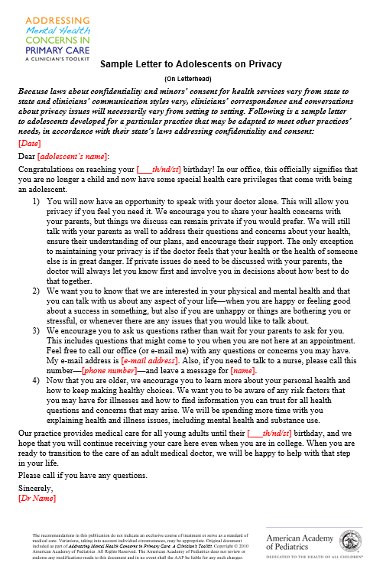 | 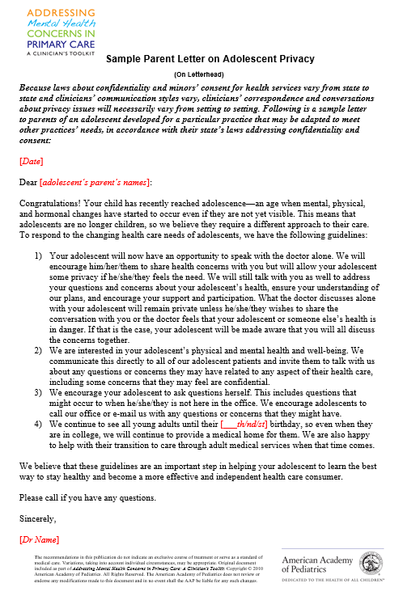

To customize the letters for use in your practice
- Sample Letter to Adolescents
- Sample Letter to Parents

